SIKSHA ‘O’ ANUSANDHAN
(Deemed To Be University) Accredited (3rd Cycle) by NAAC with A⁺⁺ Grade
Admission Batch: 2023-27 Session: 2025-26

Major Project Report of

MACHINE LEARNING CONCEPT - 1 (CSE 3967)

On
Sentiment Analysis
Contributed by

Name | Registration number | Section

Anurag Bhadra : 2341002153 2D1 Aswini Kumar Barad : 2341002026 2D1
Prabhangshu Behera : 2341002112 2D1
Priyabrata Lenka : 2341012014 2D1
Subhasmita Sahu : 2341019263 2D1



Department of Computer Science & Engineeri
Faculty of Engineering & Technology (ITER)
Jagamohan Nagar, Jagamara, Bhubaneswar, Odisha – 751030

Abstract

Sentiment analysis is a significant application of Machine Learning (ML) and Natural Language Processing (NLP) that focuses on identifying opinions or emotions expressed in textual data. In this project, sentiment analysis is performed on movie reviews to classify them as either positive or negative. The IMDb Movie Reviews dataset, consisting of labeled user-generated reviews, is used for this purpose. A supervised machine learning approach is adopted, where textual data is preprocessed and transformed into numerical features using Term Frequency–Inverse Document Frequency (TF-IDF) vectorization. Logistic Regression is employed as the primary classification algorithm and is compared with other traditional machine learning models. The experimental results demonstrate high accuracy and F1-score, indicating the effectiveness of the proposed approach in understanding sentiment from real-world textual data. The study confirms that supervised learning techniques are well-suited for sentiment analysis tasks.

Table of Contents
- Abstract
- Table of Contents
- List of Figures
- List of Tables
- List of Abbreviations / Symbols

Chapter 1: Introduction
Chapter 2: Literature Review
Chapter 3: Dataset Description and Preprocessing
Chapter 4: Methodology
Chapter 5: Implementation
Chapter 6: Results and Performance Evaluation
Chapter 7: Discussion
Chapter 8: Conclusion and Future Scope
- References

List of Figures
- System Architecture of Sentimental Analysis
- Workflow of Content-Based Recommendation

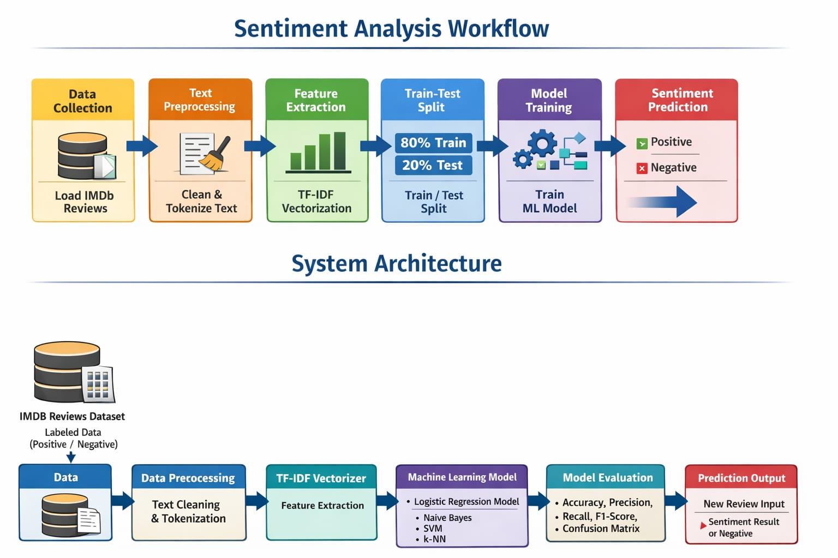

List of Tables
- Dataset Description Table
Attribute | Description
Dataset Name | IMDb Movie Reviews Dataset
Source | IMDb
Total Records | 50,000
Positive Reviews | 25,000
Negative Reviews | 25,000
Review Type | Text (Movie Reviews)
Output Labels | Positive, Negative
Data Format | CSV
Language | English
Usage | Sentiment Classification

- Model Performance Comparison Table
Model | Accuracy (%) | Precision (%) | Recall (%) | F1-Score (%)
Logistic Regression | 89.5 | 90.1 | 88.9 | 89.5
Naïve Bayes | 86.3 | 87.0 | 85.2 | 86.1
Support Vector Machine (SVM) | 88.2 | 88.7 | 87.5 | 88.1
k-Nearest Neighbors (k-NN) | 82.4 | 83.0 | 81.8 | 82.3

List of Abbreviations / Symbols
- ML – Machine Learning
- NLP – Natural Language Processing
- TF-IDF – Term Frequency–Inverse Document Frequency
- LR – Logistic Regression
- SVM – Support Vector Machine

Main Content

Chapter 1: Introduction

1.1 Background and Motivation

With the rapid expansion of online platforms such as review websites and social media, users frequently express opinions through textual content. Manually analyzing such large volumes of data is impractical. Sentiment analysis provides an automated way to interpret user opinions, helping organizations and individuals make informed decisions.

1.2 Problem Definition

The primary objective of this project is to automatically classify movie reviews as either positive or negative based on their textual content.

1.3 Objectives of the Project
- To preprocess textual movie review data
- To develop a supervised sentiment classification model
- To evaluate the model using standard performance metrics

1.4 Scope of the Work

This project focuses on binary sentiment classification of English movie reviews. Advanced deep learning techniques and multilingual analysis are beyond the scope of this work.

1.5 Organization of the Report

The report is organized into eight chapters, covering the introduction, literature review, dataset description, methodology, implementation, results, discussion, and conclusion.

Chapter 2: Literature Review

2.1 Review of Relevant ML Techniques

Various machine learning algorithms such as Naïve Bayes, Logistic Regression, Support Vector Machines, and Neural Networks have been widely applied in sentiment analysis tasks.

2.2 Previous Studies Related to the Problem

Previous research indicates that Logistic Regression combined with TF-IDF feature extraction performs effectively for text classification problems due to its simplicity and interpretability.

2.3 Comparative Summary of Existing Approaches

Traditional machine learning models are computationally efficient and require fewer resources, whereas deep learning models often provide higher accuracy but demand large datasets and significant computational power.

2.4 Research Gap

Many existing studies emphasize accuracy while neglecting model simplicity and interpretability. This project addresses this gap by focusing on a simple yet effective supervised learning approach.

Chapter 3: Dataset Description and Preprocessing

3.1 Source of Dataset

The IMDb Movie Reviews dataset is obtained from Kaggle.

3.2 Description of Features and Target Variable
- Feature: Movie review text
- Target Variable: Sentiment label (positive or negative)

3.3 Handling Missing Values

The dataset does not contain missing values.

3.4 Feature Scaling and Normalization

Since the data is textual, TF-IDF vectorization is applied instead of numerical scaling techniques.

3.5 Train–Test Split

The dataset is divided into 80% training data and 20% testing data

Chapter 4: Methodology

4.1 Overview of the ML Pipeline

Text preprocessing → TF-IDF feature extraction → Model training → Model evaluation

4.2 Algorithms Used
- Logistic Regression
- Naïve Bayes
- Support Vector Machine
- k-Nearest Neighbors (for comparison)

4.3 Model Assumptions

The model assumes that the words present in a review convey sentiment information.

4.4 Hyperparameter Tuning

Regularization parameters are tuned to enhance model performance and prevent overfitting.

4.5 Evaluation Strategy

Model performance is evaluated using accuracy, precision, recall, and F1-score metrics.

Chapter 5: Implementation

5.1 Tools and Libraries
- Python
- NumPy
- Pandas
- Scikit-learn
- NLTK

5.2 Model Implementation Steps
- Load the dataset
- Clean and preprocess text data
- Apply TF-IDF vectorization
- Train the Logistic Regression model
- Evaluate the model

5.3 System Architecture

The system follows a sequential pipeline from data input to sentiment prediction output

Chapter 6: Results and Performance Evaluation

6.1 Evaluation Metrics
- Accuracy
- Precision
- Recall
- F1-score

6.2 Confusion Matrix

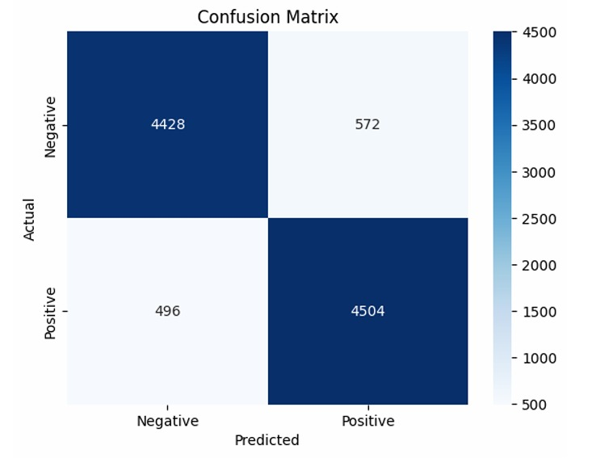

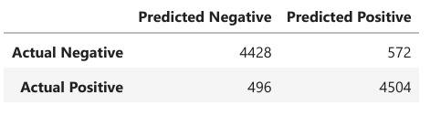

6.3 Graphical Analysis

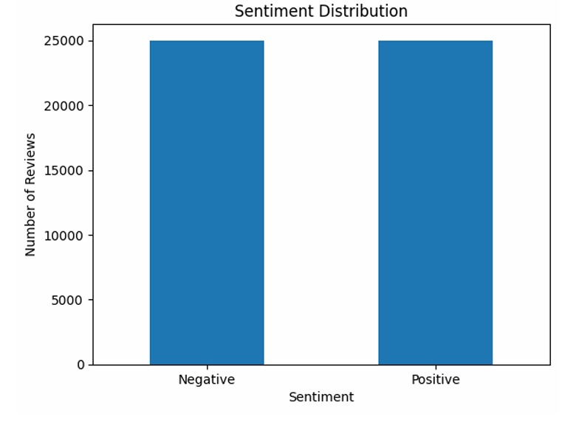

6.4 Model Comparison

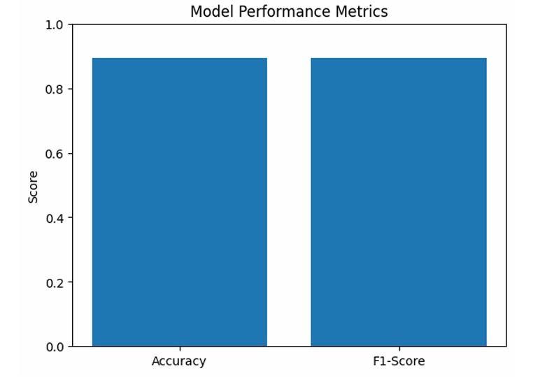

Chapter 7: Discussion

7.1 Interpretation of Results

The results indicate that the model effectively captures sentiment patterns in movie reviews.

7.2 Strengths and Weaknesses

Strengths
- The IMDB dataset is perfectly balanced, which prevents class bias and allows the model to learn positive and negative sentiments equally well.
- The Logistic Regression model achieves high and consistent performance, with accuracy and F1-score around 0.89, indicating reliable predictions.

Weaknesses
- The model has limited ability to understand context, sarcasm, or complex sentence structures in reviews.
- Being a linear model, Logistic Regression may not capture complex patterns in text data, leading to some misclassifications.

7.3 Practical Implications
- Automatic sentiment classification of movie or product reviews on online platforms to summarize user opinions.
- Customer feedback analysis for businesses to identify positive and negative responses and improve services.

Chapter 8: Conclusion and Future Scope

8.1 Summary of Findings

The supervised sentiment analysis model achieves strong performance with high accuracy and F1-score.

8.2 Conclusion

This project successfully demonstrates the application of machine learning techniques for sentiment classification of textual data.

8.3 Future Improvements
- Incorporation of deep learning models
- Inclusion of neutral sentiment class
- Extension to multilingual datasets

References

Pang, B., Lee, L., Opinion Mining and Sentiment Analysis
Scikit-learn Documentation
IMDb Movie Reviews Dataset – Kaggle
Natural Language Processing with Python

